

CA1: Advanced Programming

Module Title: Advanced Programming
Module Code: B8IT150_2022_TME2
Module Leader: Paul Laird
Student Name: Jose Maria Rico Leal
Student Code: 10539218

Contents
CA1: Advanced Programming 1
1. Introduction 3
2. Requirements 3
3. Implementation and Testing 4
4. References 11
5. License 12
6. Reflections and Thanks 12

Introduction

This project consists in a web page for a bike shop, still in an early development stage, however I would like to expand its functionality to conduct the final project (B8IT131_2122_TME2). Here we can interact with a Database that contains two tables, navigate through the 5 pages that compose the web and some other things that I will go in detail in the requirements. As per your requirement “You must use public git (e.g. GitHub) to manage your source and versioning, with regular frequent commits. Git may be used to verify engagement, and failure to engage with source control may result in a zero grade.” Please see my GitHub (https://github.com/jose-rico/B8IT150_CA)

Requirements

To establish some requirements, I am going to assume that the owner of Cool Bikes LDT, wants to create a website hosted with the following domain https://jose.dbsprojects.ie/.
The objective of this website is to expand brand reputation and to gain visibility online.
A list of owner requirements:
- to keep track of transactions users can interact with our database, I will go in more detail about this in the implantation and testing.
- Display the customers that we have worked with.
- Create a contact page for customers to send emails.
Briefly these are the requirements, good thing about the owner is that he gave flexibility in terms of web design.
At this point I want to mention the technology used:
- I have used Microsoft Azure to deploy a virtual machine, operating system Linux (ubuntu 18.04).
- Microsoft Visual Studio to make all changes to html, JavaScript, python and CSS files.
- GitHub to create a repository, all project can be found here (https://github.com/jose-rico/B8IT150_CA).
- To commit all changes into GitHub I have used Git Bash.
- To transfer all changes to GitHub using Git Bash, I have used Putty I will never forget this command “git pull”.
- To format images I am using Gimp.
The requirements I am sure will change if I take this project as the initial draft for the diploma final project.
Following your guidelines in moodle I will briefly comment them, regarding data requirements, is worth to mention that I have used Varchar and Char for tables created.
Search I think it refers to any research done when conducting the project, all I can say is that I have spend quite a lot of time researching on Google, sites like, geeks for geeks or stack overflow, just to mention two. Before asking you, for doubts, I have followed that way.

Update, validation, integrity will be comprehended in the following points.

Implementation and Testing

I have done the implementation of this project via GitHub, in total 143 commits being the initial commit on May the 2nd.
I am going to test the DB before I submit my work, here is how the DB looks like:
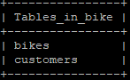
Two tables, bikes table is the one we can interact with. Table customers was created how to handle another table in flask, I had to create a separate script for this one and open port 8081 in Azure.
First of run command python3 app.py & python3 app1.py &:
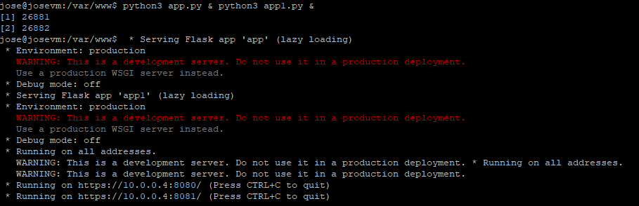

Once python scripts are running, we can see the following results:
- Page Start, we can retrieve all records that we have in table bikes, script that makes this work is app.py:
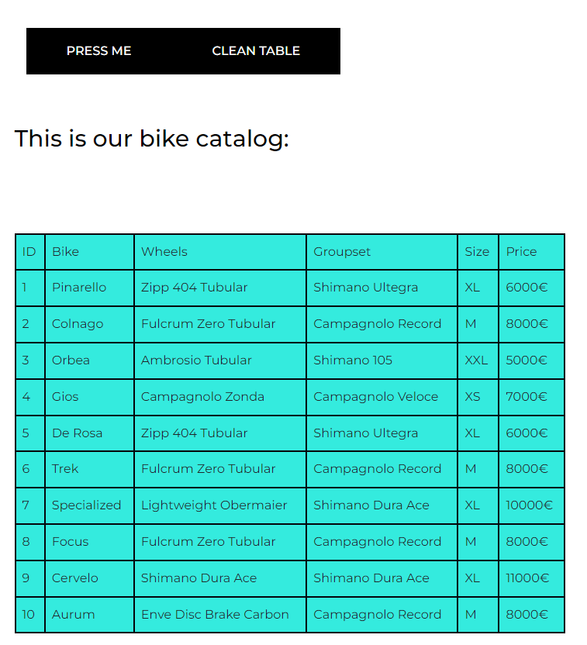
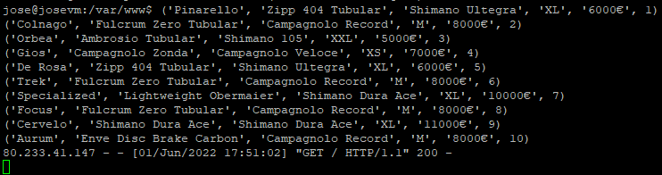

- Page customers it works in a similar way to start, just fetching data from a table, in this case table customers and python script app1.py:
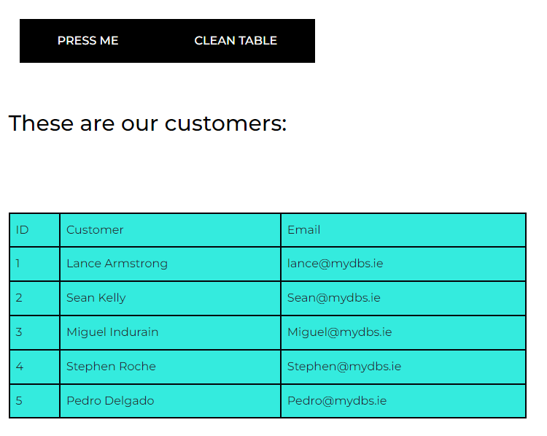
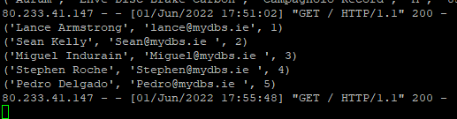

- In page custom we can add a bike, ideally for the final project we can customise a bike. Field price is for the purpose of adding a record it does not make sense the idea of a customer choosing which price to pay.
I have tested adding special characters and the string is not being recognised, therefore we cannot add a record with special characters. However, we can add a blank record if no input is written. This is something to shape thinking in the final project.
There is an alert when the bike has been added, now we are going to add a record and after retrieve the records from start page:

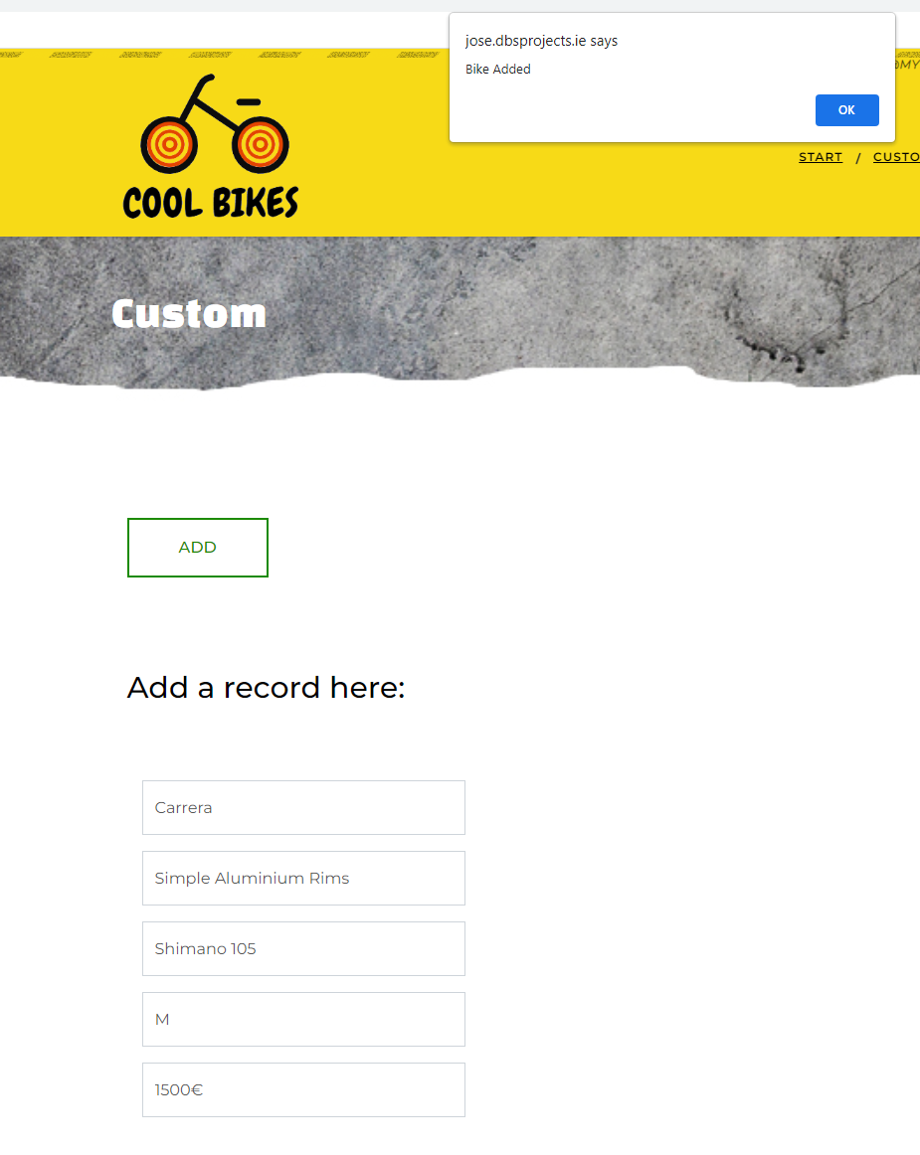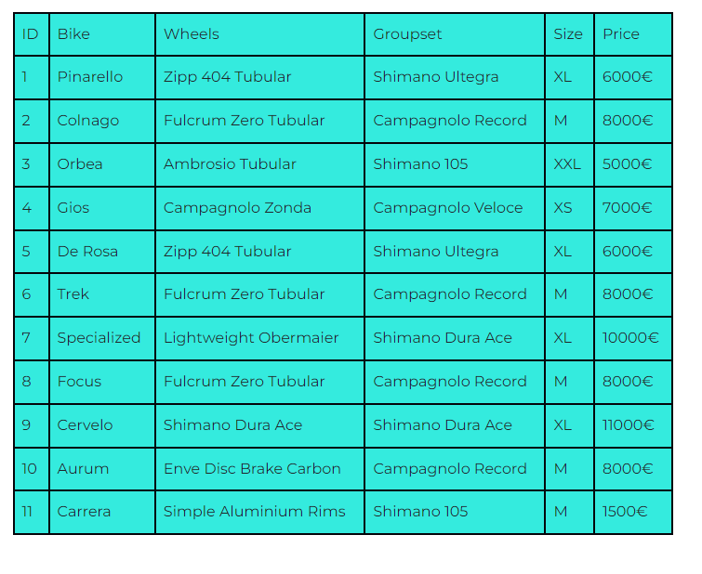
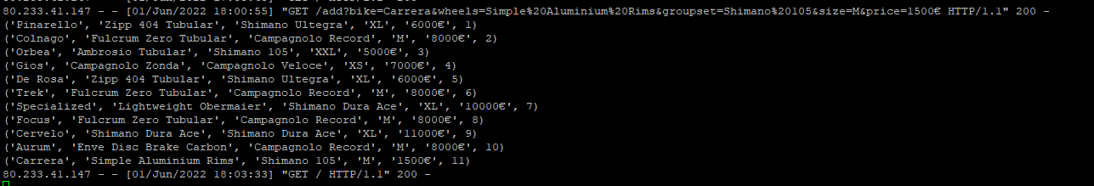

- In page Buy we can delete and modify a record. My idea here is for the final project is to set up a basket where the customers can make the purchase. For now we are going to modify record 11:
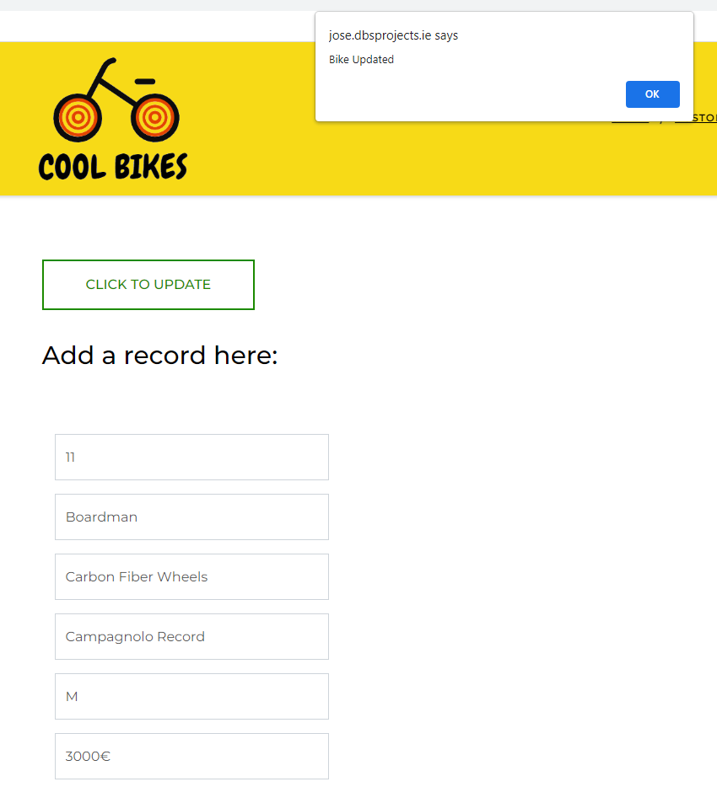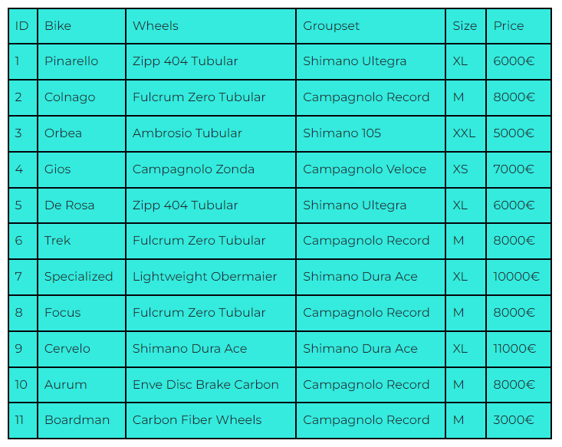

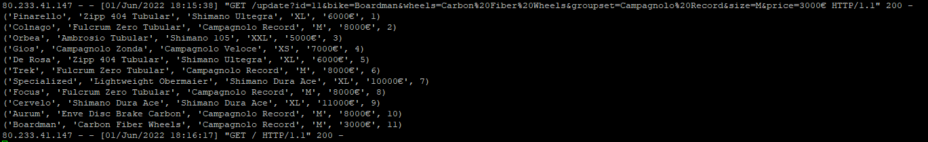
- Deleting a record:
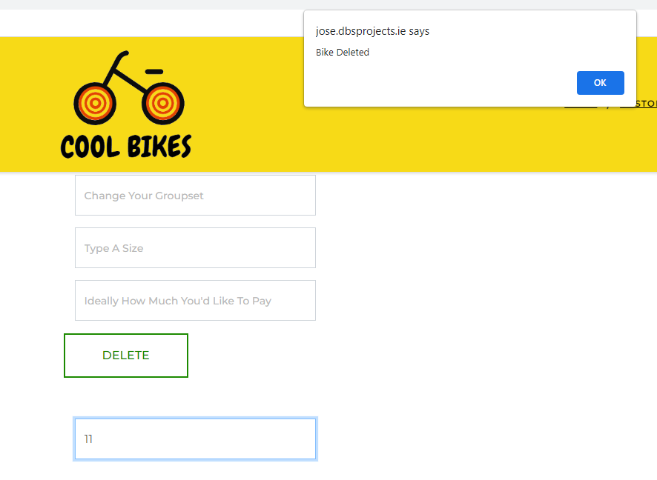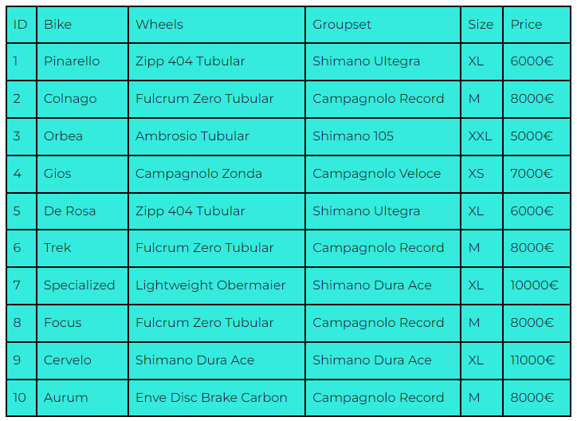
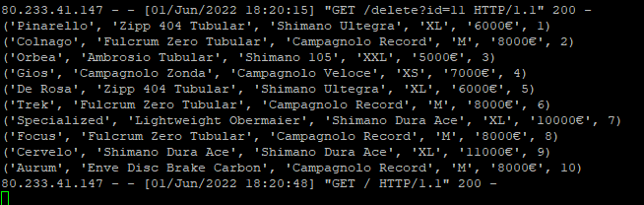

- Page contact we can submit an email:
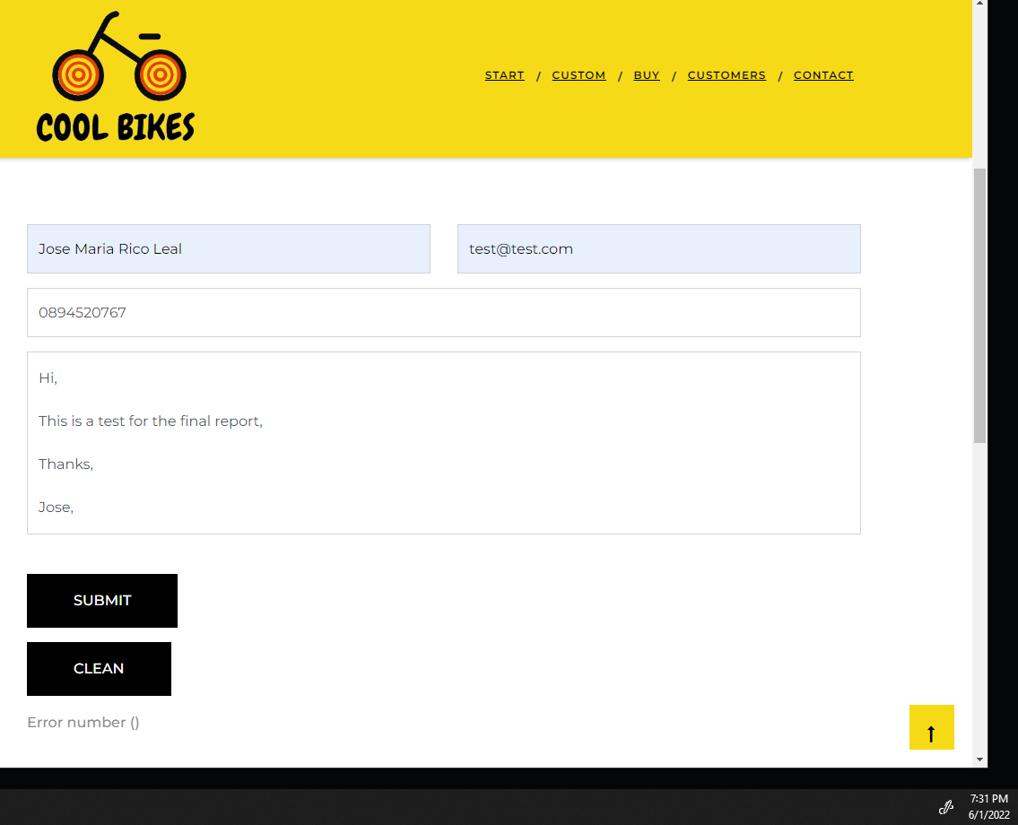

Once you submit it will bring to a Thank you page:

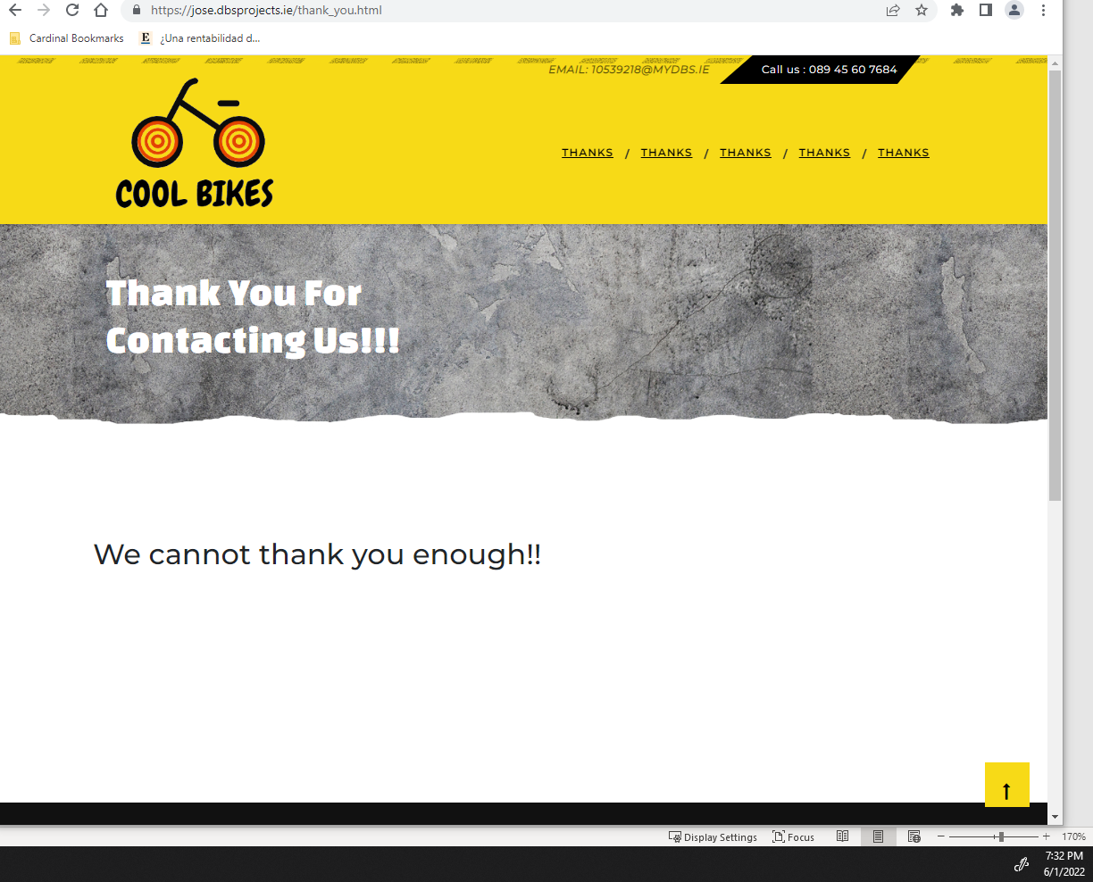

And here is the email in the 10539218@mydbs.ie inbox:
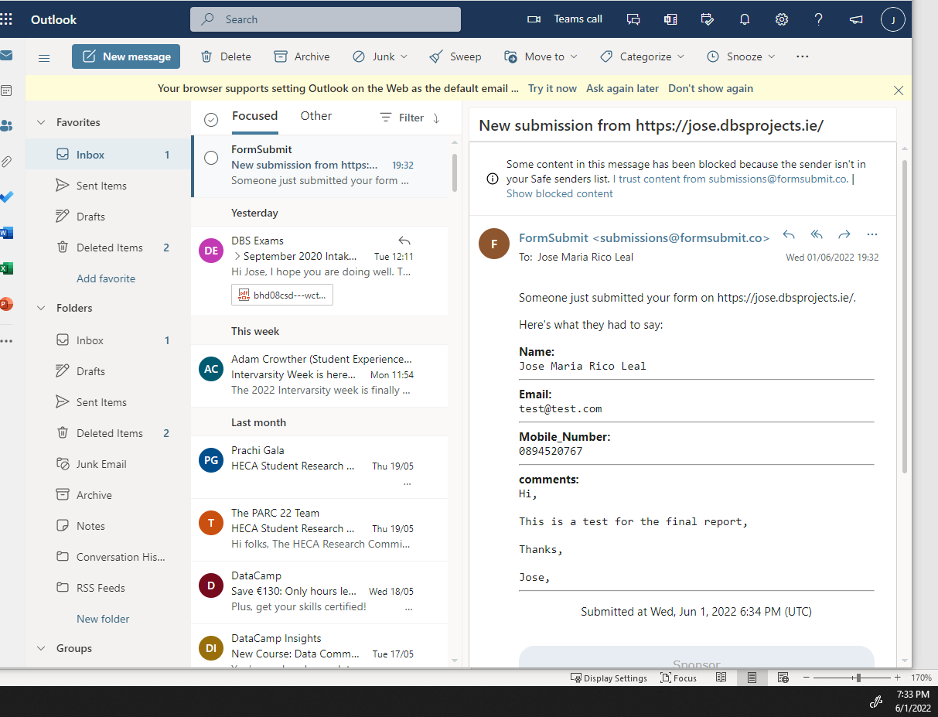

References

To comply with the point “You must attribute all code not written from scratch, either in accordance with its licence, if applicable, or if not, #taken from ... failure to do so may result in a zero grade.”
Looking at the project folder I am going to reference from where I took the code from: 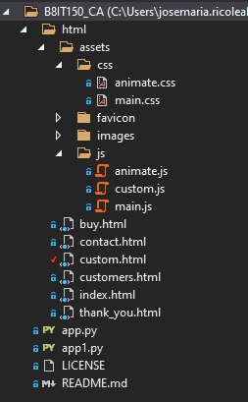
All web front end as in HTML, CSS and JavaScript it was taken from “template.net” searching for construction website templates. Initially I wanted to optimise a web page that I have done for my brother see the link here (https://construccionesmanin.github.io/) this one is not reactive at all, I have done it after last year subject web development. At the end it served me to finalise this project.
Both python scripts app.py and app1.py, come from your classes, some variations of the flask as in delete or update I have took the idea when people was sharing screen in class.
I have to reference a bit the JavaScript:
- custom.js and animate.js comes from “template.net” I have not touch them.
- main.js, Contact form function and print out error it was taken from last year web desing module. Last block of code I took the code from: www.codegrepper.com/code-examples/html/javascript+onclick+reset+page
- In buy.html there is a JavaScript block to prevent deleting a bike without a record, I took the code from JavaScript: HTML Form - checking for non empty field - www.w3resource.com/javascript/form/non-empty-field.php.
In contact page, the email submission I took the idea from this video: https://dev.to/ania_kubow/send-emails-from-a-html-contact-form-video-1jgo
I think I am not forgetting anything to reference, please Paul in case you find something that needs an explanation let me know.

License

I am using the licence that GitHub set by default, GNU General Public License v3.0:
“Permissions of this strong copyleft license are conditioned on making available complete source code of licensed works and modifications, which include larger works using a licensed work, under the same license. Copyright and license notices must be preserved. Contributors provide an express grant of patent rights.”

Reflections and Thanks
To wrap up this brief report I would like to thank you, for all the patience and guidance through this subject, I know I was not the most participative and responsive student but at least I have learnt how to deploy a web page using a VM and make that interactive. I leave the VM running with the “nohup” command on, hopefully you can test it fine .

**Note:
There are 10 records for table bikes, if you add a bike it will start with ID 13, I have tested update and delete with nohup. ***

